1.

|  |  |  |
| --- | --- | --- |
| № | Auto Trace Configuration Options | Description |
| 1 | Set autotrace on | Enable result,statistic and execution plan output in terminal |
| 2 | Set autotrace traceonly | Enable mode traceonly, which shows statistic and explain plan only |
| 3 | Set autotrace on explain | Enable result and execution plan only |
| 4 | Set autotrace on statistics | Enable result and statistic only |
| 5 | Set autotrace traceonly statistics | Shows statistic only |
| 6 | Set autotrace only explain statistics | Shows execution plan and statictic only, without result |
| 7 | Set autotrace off | Shutdown statistic and expecution plan output in terminal |

2.

2.1.Nested loop join

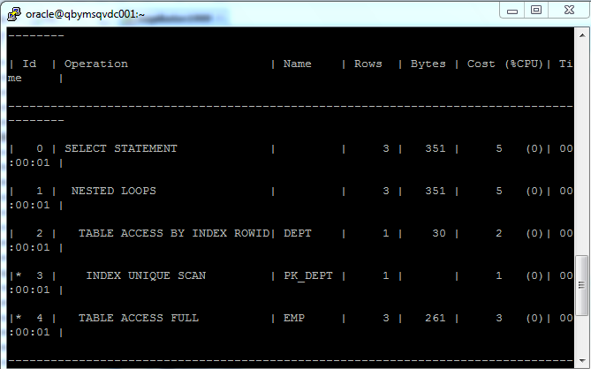

Nested loop join: For every row of outer table, access the rows of inner table. It works rapid when outer table is small and inner table has index on column which is joined to outer table.

2.2. Hash join

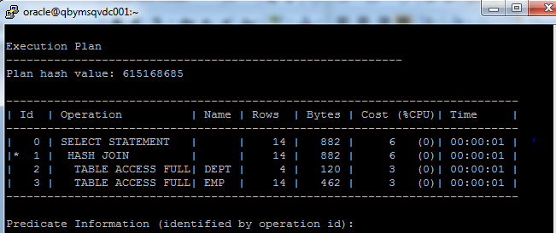

Hash joins are used when the joining large tables. The optimizer uses smaller of the 2 tables to build a hash table in memory and the scans the large tables (using windows, I mean not all table load in buffer cache) and compares the hash value (of rows from large table) with this hash table to find the joined rows. The builds FIFO stack for matched values (push matched)

2.3. Sort Merge Join

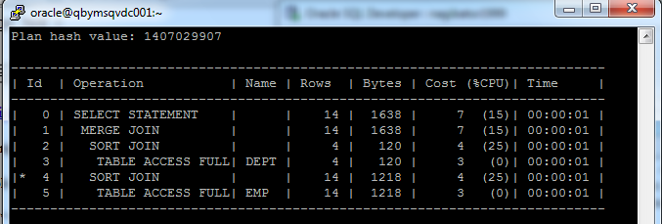

Sort merge join sort joined columns of both tables and highlighted similar subgroups (doubly linked list). Then merge it. It works fast when both joined columns have index or result set of rowid (when index) is not equal to second table dataset.

2.4 Cartesian Joins

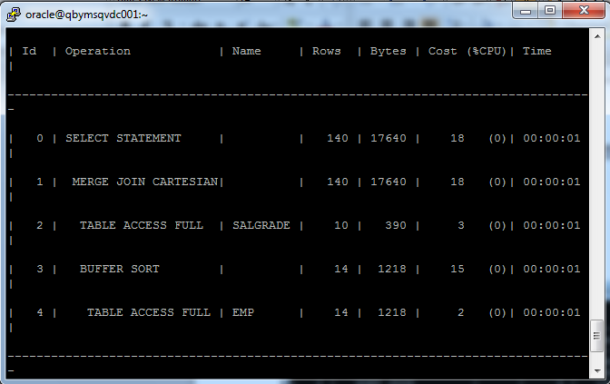

Cartesian join is a join of every row of one table to every row of another table.

2.6 Outer Join

2.6.1 Left/Right Outer Join

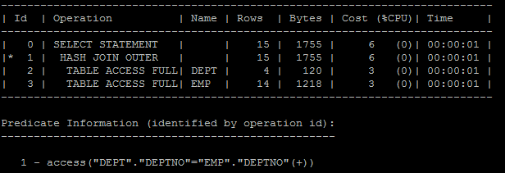

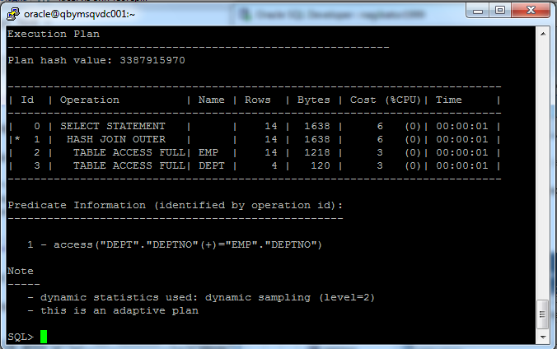

Left outer join: all values of left table joins with right (using hash, NL or SM joins). Unmatched rows from the first (left) table, joining them with a NULL row in the shape of the second (right) table.

Right outer join: same as left but for right table

2.6.2 Full Outer Join

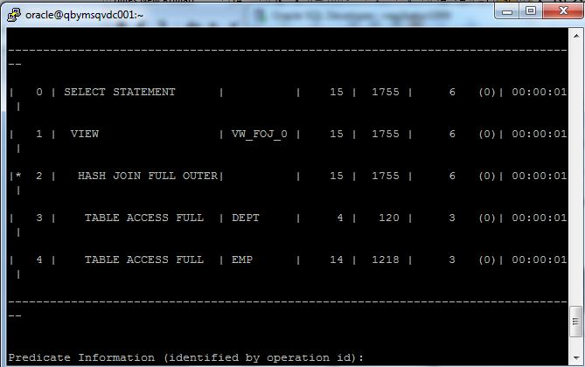

Unmatched rows of both tables joining with null rows.

2.7 Semi Joins

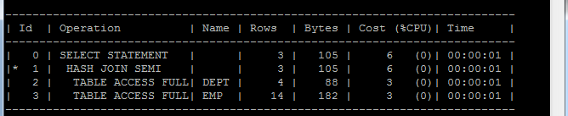

A semijoin returns rows that match an exists subquery without duplicating rows from the left side of the predicate when multiple rows on the right side satisfy the criteria of the subquery.

2.8 Anti-Join

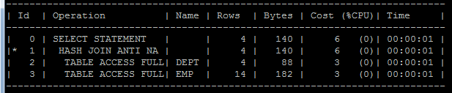

An antijoin returns rows from the left side of the predicate for which there are no corresponding rows on the right side of the predicate. That is, it returns rows that fail to match (not in) the subquery on the right side.

2.9

|  |  |  |  |  |  |  |
| --- | --- | --- | --- | --- | --- | --- |
| Join Access “A” | Join Access “B” | Nested Loop | Hash Join | Sort-Merge Join | Anti-Join | Semi-Join |
| Small Table | Small Table | 113 | 6 | 6 | 6 | 6 |
| Small Table | Indexed Big Table | 203 | 61 | 420 | 61 | 61 |
| Indexed Small Table | Indexed Big Table | 162 | 61 | 420 | 61 | 61 |
| Small Table | Big Table | 5626 | 61 | 443 | 61 | 61 |
| Big Table | Big Table | 5622554 | 317 | 880 | 297 | 297 |
| Indexed Big Table | Index Big Table | 200122 | 317 | 857 | 297 | 297 |
| Indexed Small Table | Big Table | 162 | 61 | 442 | 61 | 61 |
| Indexed Small Table | Indexed Small Table | 103 | 6 | 5 | 3 | 3 |